The trend the trend oh where art thow trend?

You know when I first got into trading his was the question that plagued me most. What direction is the trend really in????

I mean let’s face it; we pull up a weekly chart to see that we have a nice strong bullish trend. Then we look and the daily and we see a god representation of that bullish trend but with clear areas of pullbacks and continuations. Then we drop to a 4 hour chart and the confusion starts to set in because we see a bearish trend and we are missing out on great profit opportunities during this period. But wait the trend is supposed to be bullish so what the heck am I supposed to follow; the weekly daily or 4 hour trend direction? And how to we know that the trend has reversed and we should be looking for trades in the opposite direction.

I beat myself silly trying to figure this all out and used tools like ADX, RSI, CCI, and MACD to indicate what direction the trend was in. I drew trend lines and channels; I read my horoscope and checked the star constellations all to help me determine the trend direction and what direction I should be trading. They all have value in there own little way. Only I do not use them because they cannot tell me anymore than what I can see on the chart alone.

Then one day the light bulb went on and lit the path that would eventually change my trading career from being one of confusion, and frustration to one that allows me to relax see what is really happening on a chart and with a truly methodical approach.

Now most of you who have read my previous posts have seen that I favor the 1-2-3 setups. These little setups are quite powerful. I am not going to get into details about entries and exits here but rather hopefully help you understand how I look at charts to determine a bias for bullish or bearish setups. So it will be my opinions of how I determine the trend and what direction I look to take trades.

So without further ado let me crack open my little noggin and let you see the charts through my eyes.

First we see here a current weekly chart of the GBP/USD I have chosen this pair due to some of the questions that were asked previously.

Clearly the trend is in an upward direction… bullish indeed.

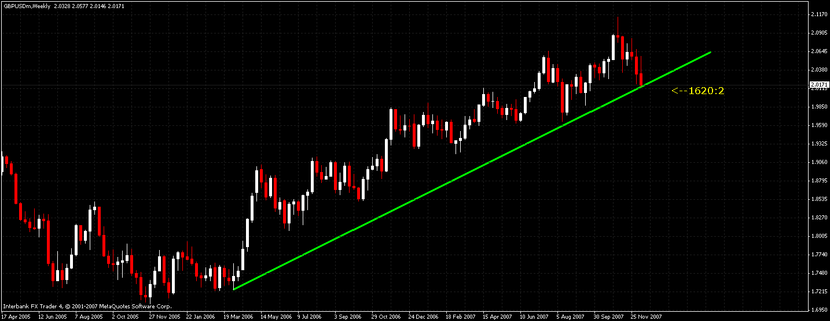

Now here on the daily chart we see that again we are in a nice long bullish trend. I had to zoom out a bit so you could see the trend line I drew from the weekly chart.

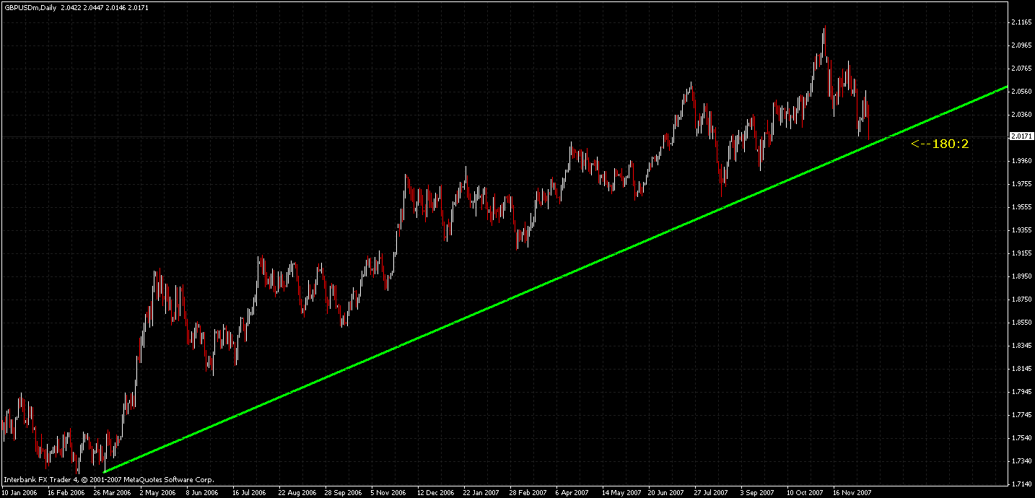

And here you will see the 4 Hour chart with the same bullish trend line from the previous charts. I was unable to fit the whole trend on this chart even MT4 has its limitations ☺. But look closely. I have drawn additional bearish trend lines which occur during this long term bullish trend. It starts to become a little clearer in the next chart how the confusion in trend direction can start to set in.
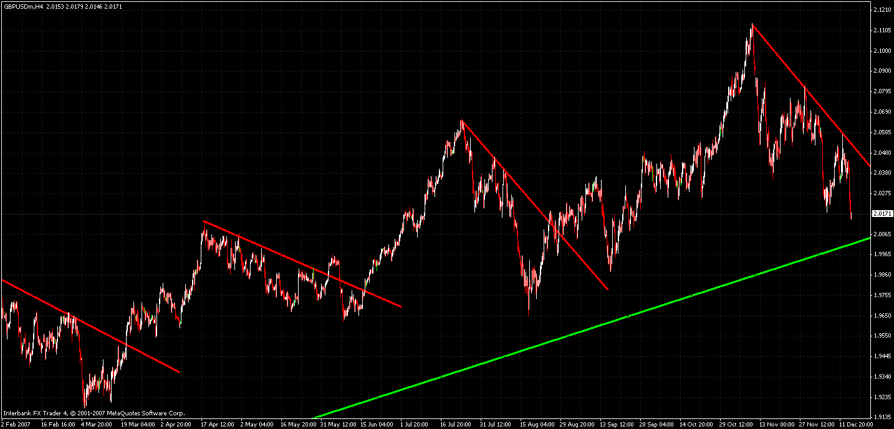

When we look at charts we normally look at many less bars or candles than what I showed previously. This chart is a typical representation of what we would normally see. And as you can see the weekly and daily bullish trends have disappeared and we see bearish trend in action.

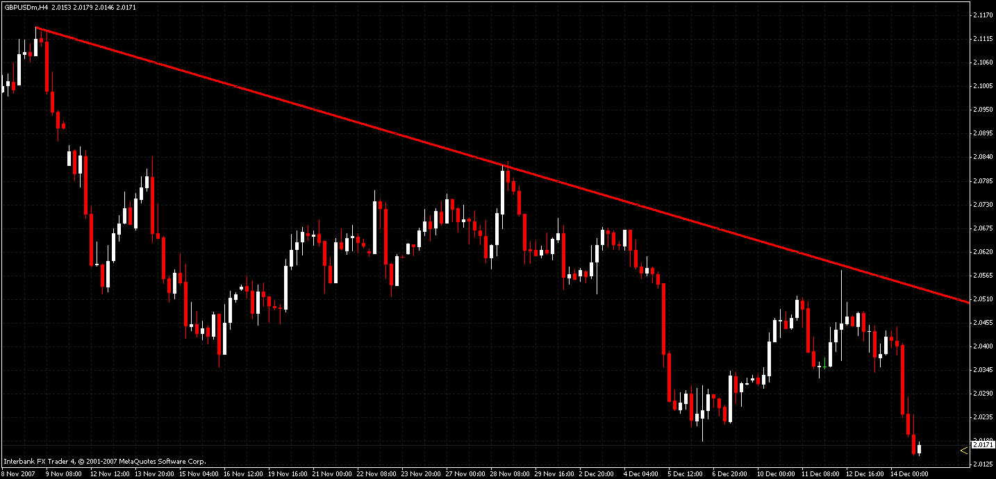

So how can we make sense of it all and what are we to do as traders? Well for starters it is absolutely imperative to grasp that concept that all shorter time frames ultimately create what we see on the higher time frames. Let’s look at the next example shall we.

I want to draw your attention to the area between the 2 vertical lines on the weekly chart. This is a short term pullback from a much stronger and longer term up trend. You can see there was a good period of time where prices trended downward before resuming the major trend direction. Now ask yourself this question; what would you as a trader have done knowing that there is a strong uptrend in place. Would you have spotted opportunities to catch some moves on this pullback or would you have waited for the longer term trend to resume? One thing to keep in mind is we never know when or if the trend will ever resume. That’s why traders like us are called speculators ☺ We speculate that the market will move in a one direction or another.

So where on this weekly chart is the first sign of weakness? Where is the first indication that this is now a downward trending zone? The answer is clearly at the swing high indicated by the blue box.

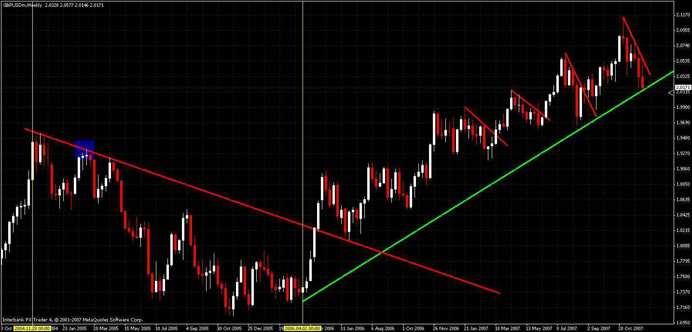

So let’s zoom in a bit closer and see if there is something else to be gleaned from how the shorter term time frames make up what we see on the longer term time frames.

This is a snapshot of the beginning of that pullback we saw on the weekly chart shown here on a 4H chart. Clearly there are some prime opportunities here to enter some nice short trades against what we would otherwise consider a strong up trending market. Notice the blue box that was on the weekly chart. On the weekly this area is the swing high that clued us into the fact that the trend may be changing. But on the 4H we can see that thee were indications much earlier on that the trend may be changing.

Hence what we see on a shorter term chart i.e. 4H ultimately makes up what we see on a longer term chart i.e. Weekly.

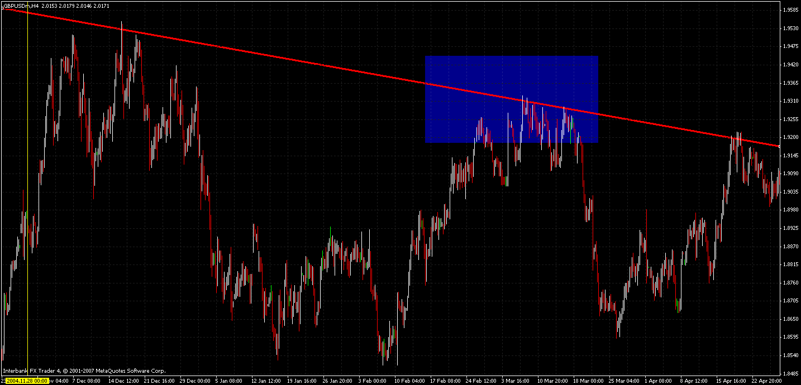

So now you’re sitting there thinking wow this is great info but how do we use it to make trading decisions? Well here is how I use it to make trading decisions. First let’s start with a clean chart, all these lines get in my way of seeing price ☺

I want to focus on one area of time on this chart. I have highlighted this are in blue on the weekly. When looking at this area it is clear to see that leading up to here we are in a clear up trend. What I like to do is look to see what the market is doing on the weekly but base my decisions on a 4H chart. The arrow indicates the completion of a swing point on a weekly time frame. So obviously we are looking to see where we can find some bullish setups on a 4H time frame.

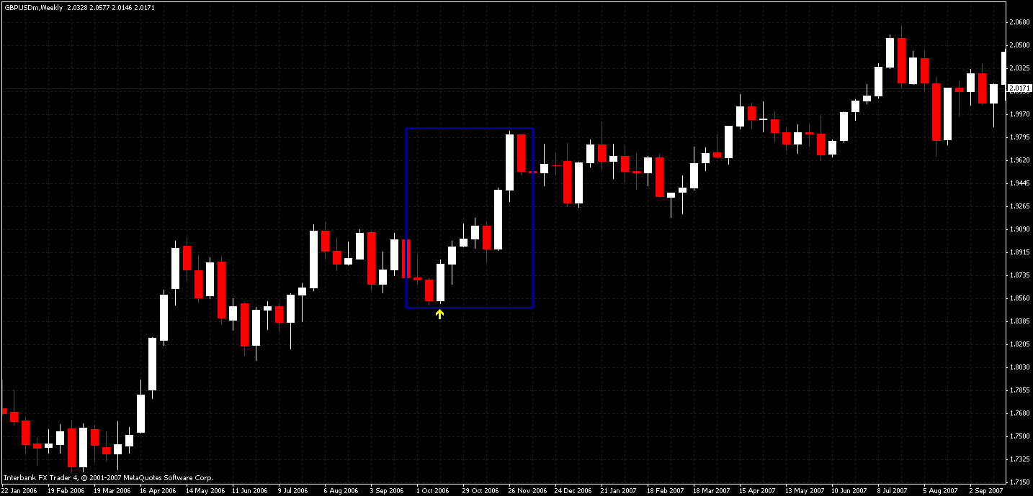

So now here on the 4H chart we can see there were numerous opportunities to cherry pick your best setups and make some great trades. But just because we are in an awesome up trend there would still be opportunities to short this pair. This is why I look to the longer term charts for formations and overall trend direction and base my trading decisions (entries and exits) on the 4H charts. So in essence I trade the trend of the time frame I am basing my trades on and refer to he higher time frames for additional price action setups.

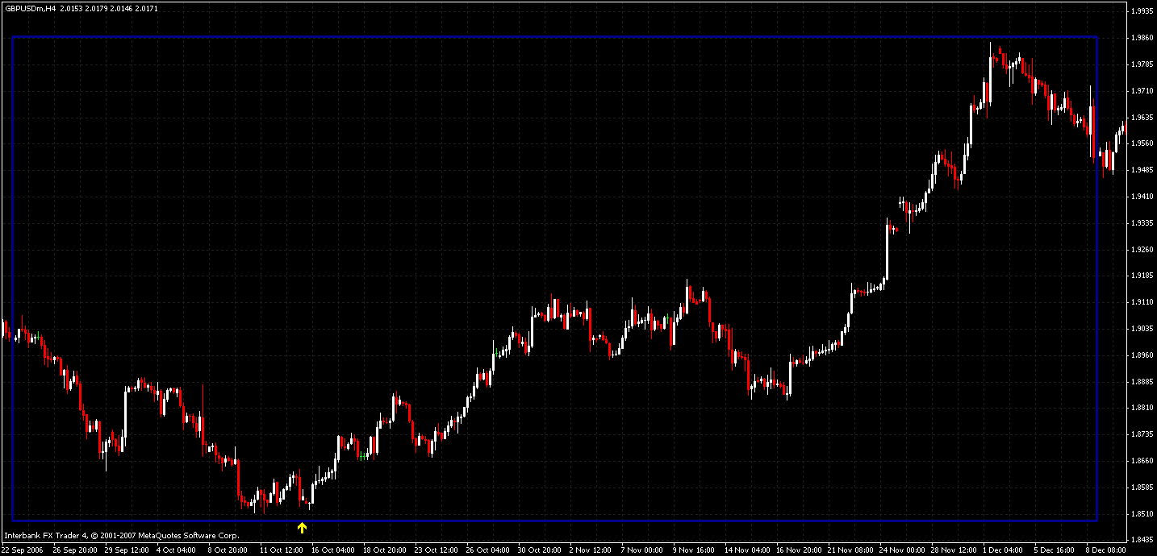

I know this is not a comprehensive trading manual and of course it is not supposed to be. This is merely my way of being able to share how I look at the charts and use the different time frames.

